Guideline Initial sample Inspection Report
- Purpose
The purpose of the Initial sample inspection report Guideline (ISIR) is to present HOBART's minimum requirements for the supplier in the initial sample process.

- Definition
Before the series release can be issued the product must be manufactured under controlled, reproducible, and robust process conditions = series condition.
Series conditions are defined as following:
- Series production means available (equipment, machines, tools, test equipment etc.)
- On site
- with serial material
- with full capacity
- using regular personnel
- be in operation with all supporting systems

The supplier evaluates the readiness for series production on his own responsibility.
The ISIR can only be created and submitted to the customer after internal process acceptance by the sales, production, and QM department.
With the ISIR, the supplier can provide evidence that the delivered products meet the quality requirements of HOBART.
The initial sample approval freezes the process.

- Occasions and reasons for ISIR
The following occasions or reasons require the performance of an ISIR:

HOBART
New part
Change (Drawing, specification, design etc.)

Supplier
All changes that have or can have an influence on the product quality (process changes, relocation, etc.).
Suppliers are generally obliged to have planned changes approved by means of the form “QM-006 Change Proposal/Supplier Change Request”.
This must be done at an early stage so that possible effects can be assessed in detail and the scope of the
new /supplementary sampling can be defined without risking the supply of parts.

- Scope of ISIR
ISIR requirements shall be coordinated between HOBART and the supplier. The requirements are transmitted via the HOBART document „QM-01_Sampling Requirements” and must be confirmed by the supplier.
The exact scope of the inspection report as well as the content and structure of the documents should ideally or to avoid duplication of work to be coordinated with HOBART in advance.
The official HOBART drawings, component standards/specifications, ordering instructions and other requirements provided by HOBART are decisive for the scope of the ISIR.
The scope and level of detail depend on the complexity of the products and processes to be submitted via ISIR.

- Procedure of Initial sampling inspection report and approval
The submission of components not conforming to the specifications is not permitted.
In this case, HOBART must be informed, and the further procedure coordinated.
If a part delivery is required, a deviation request “QM-004 Deviation Permit” must be submitted.

The evaluation of the Initial sample inspection report is carried out by HOBART’s quality management.
After reviewing the documents and, if necessary, after cross checking the initial samples, HOBART will send the
Supplier one of the following decisions:

Approval
The delivered products/samples including the documentation submitted fully comply with the specifications.

Based on the initial sample inspection report, HOBART assumes that the data has been determined properly and truthfully by the supplier.
An Approval can also be issued without cross-checking by HOBART based of the contents and confirmations submitted.

Conditional approval
The delivered products/samples including the documentation submitted do not fully comply with the specifications.

Rejection
The products/samples supplied, including the documentation submitted for sampling, deviate from the HOBART specifications.
The products must not be delivered as series parts. After the defects are corrected a new submission must be made.

Series deliveries by the supplier may only be made after the initial sample has been approved. If the initial sample inspection report is missing or rejected, a deviation request “QM-004 Deviation Permit” must be submitted by the supplier for a delivery.

- Requirements for the content of ISIR
Unless otherwise agreed for an initial sampling inspection report, verification in accordance with
HOBART Level 2 shall apply.

Level breakdown:
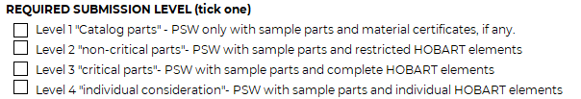

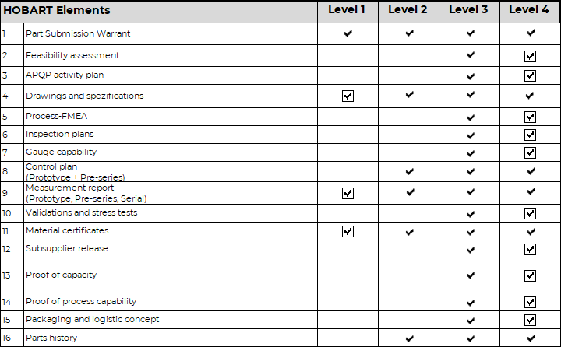

Hobart Elements / Requirements | Explanation
Part submission warrant | - Hobart template or own cover sheet, if identical in content  - Clear identification of the sampled item (Hobart item number, Hobart drawing number, revision level, item designation).  - Contact person at the supplier responsible for the release  - Formal confirmation of the guideline initial sampling
Feasibility assessment | - Hobart template or own template, if identical in content
Quality advanced planning – activity plan | - Q-Project plan. Deadline setting for individual HOBART elements or own project plan template, if identical in content.
Drawing and specifications | - Positioning is based exclusively on the official documents provided by HOBART (drawing, component standard, other specifications).
Process - FMEA | - Hobart template or own cover sheet, if identical in content  - Alternative risk assessments can be performed instead of FMEA
Inspection plans | - Inspection plans with reference to the respective operations/process steps
Test equipment capability | - The test equipment must be capable in terms of repeatability and reproducibility. Proof of suitability must be provided on request.  - - The following applies as a guideline: The measurement and test equipment uncertainty should not exceed the value of 5% - 10% of the smallest permissible tolerance of the measurement and test criteria.
Control plan | - Hobart template or own cover sheet, if identical in content  - Process sequence, description of the process, machine number and name, documents attracted (inspection plans, work instructions, reaction plans, etc.).
Measurement report | - Hobart template or own cover sheet, if identical in content  - Hobart drawing with positioned dimensions  - Reference to sample parts and original measured values of each measured part.  - Measured values must be provided for all dimensions and specification requirements (a qualitative assessment, e.g., "I.O.", is not permitted).
Validation reports | - Evidence to confirm the requirements
Data sheet / material certificate | - Proof of the specified materials (e.g., base materials, alloys, granules, confirmation of coatings, etc.) by submitting the data sheets and or material certificates.
Subsupplier release | - Cover sheet with control plan or process flow chart if any
Proof of capacity | - Hobart template or own cover sheet, if identical in content  - The supplier is responsible for carrying out a capacity check based on the demand quantities communicated by Hobart.
Process capability | - Process capabilities to be defined on an individual basis.
Packaging and logistic concept | - Hobart template or own cover sheet, if identical in content
Parts history | - Hobart template or own cover sheet, if identical in content

- Requirements regarding the scope of testing
Unless otherwise agreed, the following requirements apply about the scope of testing:
The test must be performed on at least 5 components. This also applies to all individual parts of an assembly defined by HOBART.
In the case of processes with several cavities, the complete number of cavities must be indicated on the initial sample inspection report and performed on at least 2 components per cavity.
A deviating scope of testing can be proposed by the supplier and agreed with HOBART.
Requests for changes or suggestions regarding the requirements must be submitted at the beginning of the project or in the sampling coordination meeting between the supplier and HOBART.

- Delivery / marking of the initial sample parts and documentation
Documentation must be sent in digital form.
The following file naming and structure must be adhered to:

Folder naming:
Date_Hobart Part number_Part description_reason for ISIR

Document naming:
HOBART Element_ Document name

Example according to HOBART level 3:
